Title: Availability and accessibility of biomass residues in the tropics
Name: Filip Vandeputte

Abundance of biomass residues
With a population of over 8 billion, food production in agriculture is massive; to such an extend that world’s land use is changing much in favour of agriculture at the cost of natural forests.
Based on data from FAO (www.fao.org/faostat/en/#data/QCL) world’s agricultural food (crop) production is calculated, for the year 2021, at 11.3 trillion metric tons. The corresponding cultivated area is estimated at 1.65 trillion ha (size equivalent to Russia).
Considering an average “residue to product ratio (RPR)” between 1 and 1.5, as illustrated in following table for a selection of crops, as much as 15 trillion tons of biomass residues are produced in the world.
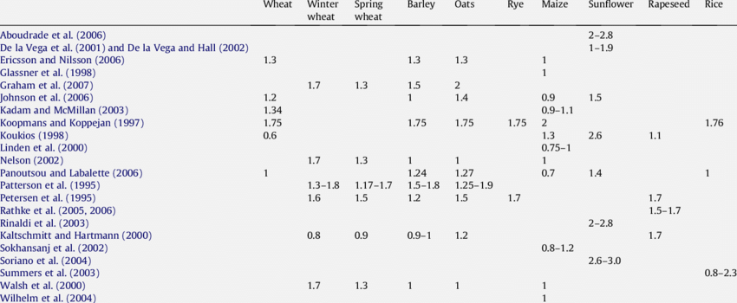
Table 1: residue to product ratio (RPR)
Due to the abundancy of biomass the world as well as the fact that the decomposition of these hydrocarbon residues create natural carbon emissions (as CO2 or CH4), it seems obvious to use these residues as fuel or feedstock for chemical industry, thus substituting fossil fuels.

Importance of bio residues in agriculture
Residues are more than just hydrocarbons as they also contain small but still important quantities of nutrients vital for growth of crops. If used for combustion or chemical extraction the nutrients (N, P, S, K, etc), are to be returned to the farming land.
Many biomass power & heat plants have recently successfully been put in operation in many countries (e.g. France, China, India, etc.) respecting circularity of nutrients and not affecting the fertilizer consumption of the resp. farming operations. The ashes being a waste for a power or heat plant are disseminated over the farming field where they are absorbed and stored into the silt, humus or clay soil to be released slowly during the growth of the crops.
However if soils lack the capacity to accumulate the recycled nutrients, these are lost and will have to be compensated by synthetic fertilizer(NPK) that is engineered to release its nutrients slowly.
The tropics which are characterized by continuous high temperature and rainfall have soils that were completely leached out of any substances with capacity to store nutrients. Therefore, their crops need rotting biomass providing the building elements. Typical for tropical forests is the massive amount of living and dead material above soil, from which diverse plants and animals take what they need and therefore are interdependent.
According to Brittanica Encyclopedia such a type of soil (Latosol) is predominant in the whole tropical area on the 4 continents as indicated in the map below:

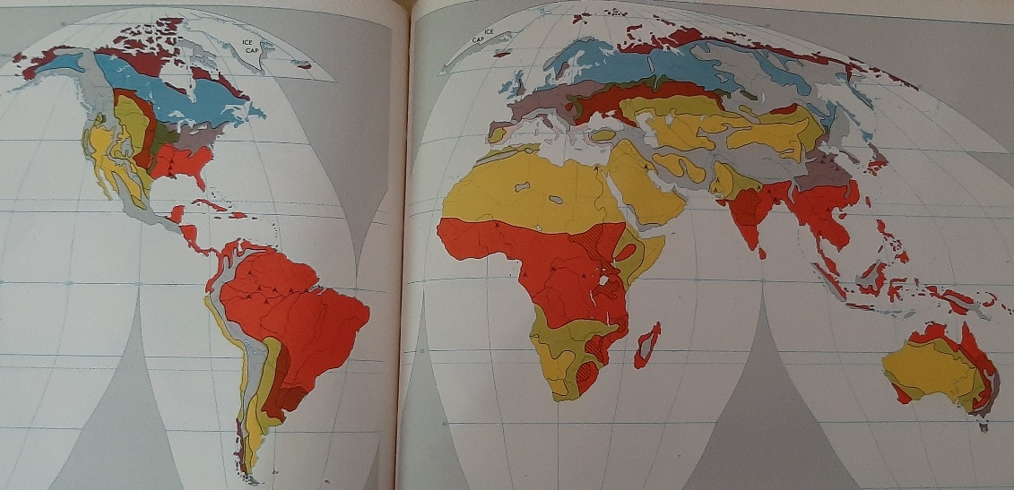
Map 1: Soil composition in the world.
Red area indicates Latosol: a reddish or yellow lateric soil of the tropics, deeply weathered and infertile, characterized by hydroxides of iron(red) and aluminium (yellow).
This representation, which is a generalisation, does not indicate local differences such as areas with alluvial, volcanic or biochar deposits.
Along the Amazon in South America, small very fertile areas have been discovered where, probably due to human activity, soils have been enriched with charcoal.
These are called “Terra Preta”, and owe their characteristic black colour to the weathered charcoal content. This soil is a product of indigenous soil management and slash-and-char agriculture. The charcoal is stable and remains in the soil for thousands of years, binding and retaining minerals and nutrients.
It is estimated that “Terra Preta” makes up to 3 % of the Amazon basin; the fertility of these soils allowed for the development of numerous settlements with a relatively high population in ancient history.
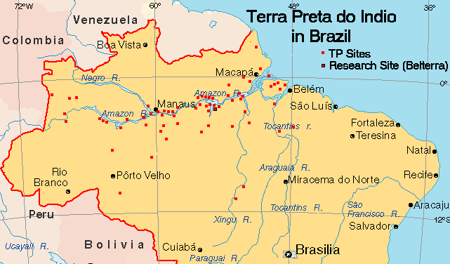
Map 2: Terra Preta sites in Amazon basin
These findings prove that agriculture in the tropics is possible if biochar is mixed to the soil enhancing the nutrient absorption.
As latosol soils have not the capacity to withhold nutrients, the nutrients must be accumulated above ground, hence no residues in tropical agriculture are wasted or removed.
However, this could completely change if roots would be embedded in “biochar”.
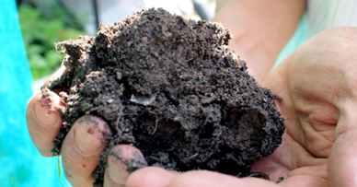
Biochar is a black, highly porous, lightweight, fine-grained substance with a large internal surface area. More than 75 percent of its composition is carbon. The remaining percentage consists of various chemical compounds of nitrogen, hydrogen, oxygen among other elements. Biochar’s chemical composition varies depending on the feedstocks used to make it and methods used to heat it.
By means of example following table gives the analysis of biochar from 3 crop residues. Biochar has a high internal surface which can be seen on microscopic photos of the 3 samples below.
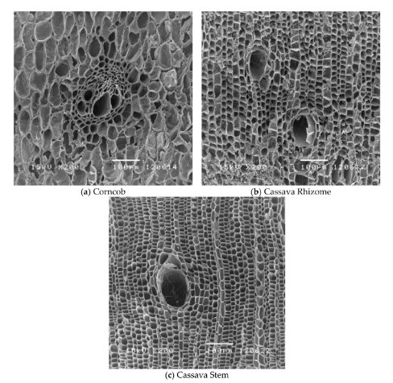
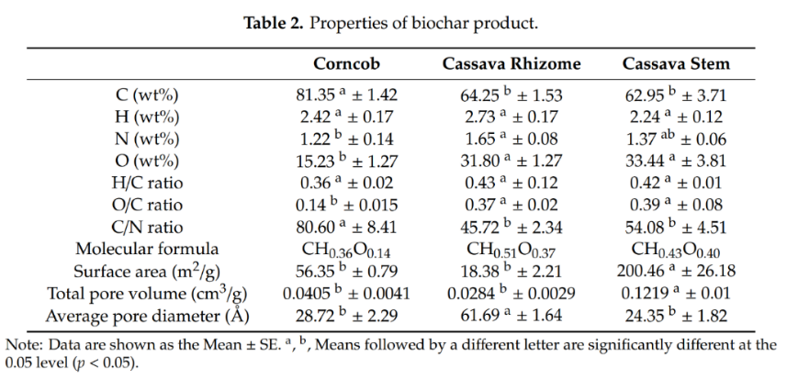

Biochar is produced by pyrolysis of biomass, which is basically heating the biomass up to temperature above 800 °C (1,470 °F) in absence of air or oxygen. During this heating much of the biomass will gasify, having biochar as a side product of biomass gasification and syngas production. Gasifiers produce up to 20 % of biochar.
Biochar production needs to be part of the biofuel production chain; torrefaction - gasification (syngas, methanol reaction). Proportionally to the extraction of residues, biochar (with ashes) must be returned to plantations, improving absorption capacity of soils and consequently capturing nutrients from ashes and reducing nutrient and fertilizer demand.
Imbedding trees and plants in a soil mixed with biochar will significantly reduce the nutrient leaks.
As biochar production in the world is still limited, extra production capacity must be installed for fast soil enhancement in the tropical agriculture.
.

Typical tropical crop: Oil palm
Oil palm plantations are controversial as the expansion of this industry has caused massive deforestation and therefore is threatening biodiversity, indirectly enhancing climate change and often, due to extensive use of pesticides and herbicides polluting the local environment.
These problems have been recognized by palm oil consumers and initiated the creation of certification systems to promote more sustainable operations and avoiding further expansion of the estates.
The “Round table for Sustainable Palm oil” RSPO, being the most respected certification organization, requires its members to fulfill sustainability criteria that cover all aspects of sustainable farming incl. social, environmental, climate, forest restauration, etc.
RSPO plantations need to set up GHG (Green House Gas) emission reduction plans; therefore, it would be beneficial to them to reduce fertilizer consumption and emissions (CO2 & CH4) as well as being a producer of sustainable fuel.
Although some attempts are made to use residues from their operations to generate electricity and power transport (biogas), most plantations struggle to come up with significant GHG reduction projects.
Most of the projects so far, resulted in an increase of operational cost and loss of productivity due to extra nutrient losses with the extraction of residues.
A palm tree has four main components: roots, trunk, fronts and fruit bunches (FFB).
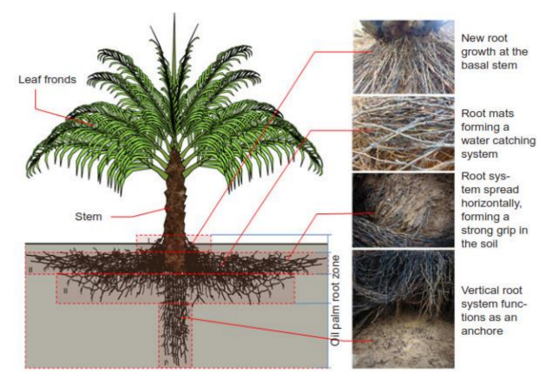
The oil palm tree is a typical tropical plant with special root structure.
The root circle is concentric to the trunk and mostly covering the top layer of the soil, with low capacity to absorb nutrients from the draining water.

Fruits are harvested every three months by cutting off the FFB from the trunk top.
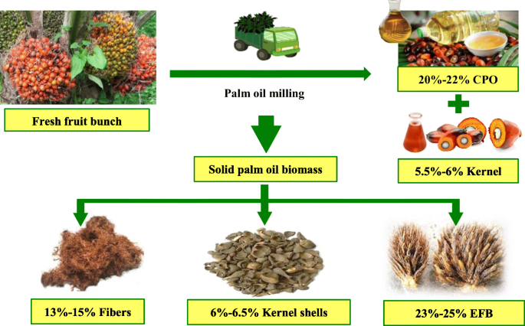
To access the ripe FFB a front needs to be cut and is left on the ground, whereas the FFB (15 to 30 kg) is transported manually to the nearest loading place.
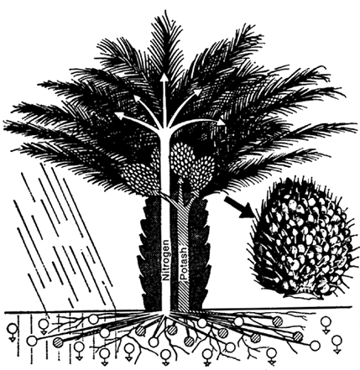
CPO (crude palm oil +- 3,5 t/ha/y) and kernel shells are sold, EFB (Empty Fruit Bunch) is returned to plantation and fibres burned in boiler for steam and power too run the mill. Not mentioned on the drawing is the palm oil mill effluent (POME) which is commonly digested anaerobically in open or closed basins producing biogas. On average POME may contain up to 50000 mg/l COD, 25000 mg/l BOD and 6000 mg/l oil and grease. As mills do not have applications for the gas, it is often flared or released to atmosphere. Digester sludge is rich in nutrients and can be returned to plantations. However, due to the poor quality of the soil, the nutrients will be drained away fast and not absorbed by the trees,
Complete FFB (full fruit bunches) removal at harvest would result in 260 kg/ha/yr loss of nutrients (ref. 1). This loss is one third of the oil palm’s annual nutrient demand. Even if the EFB are returned to the fields and applied as EFB mulch, this would replenish only 27% of the nutrient losses. The remaining losses are compensated by additional fertilizer.
Unfortunately, tropical agriculture cannot rely on such a sophisticated system and must compensate the nutrient shortage by slowly decomposing residues in combination with slow-release fertilizer.
Slow-release fertilizers release a small, steady amount of nutrients over the course of time. The fertilizer is coated with plastic resin or sulphur-based polymers which slowly break down from water, heat, sunlight, and/or soil microbes.
If residues would be taken away and used for power or heat generation, nutrients could be returned to the plantation. Unfortunately, this does not help the growth of plants, as the nutrients are very soluble in water and would also (as for digester sludge) be leached out rapidly before being taken up by the roots of the palm tree.
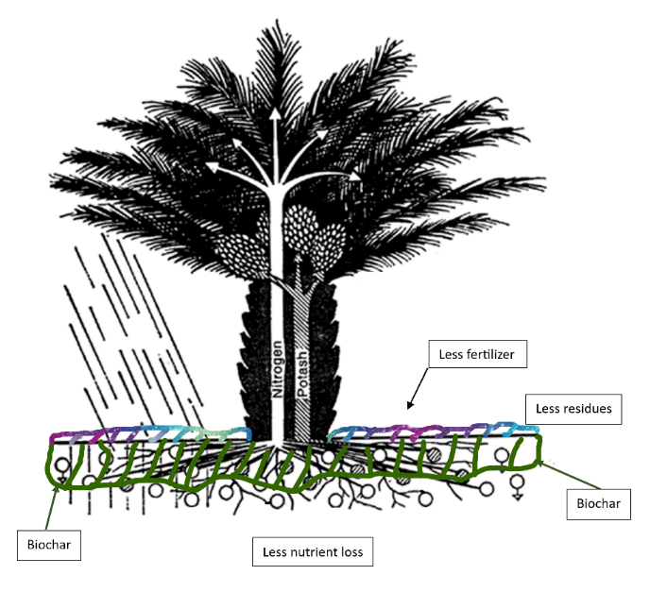
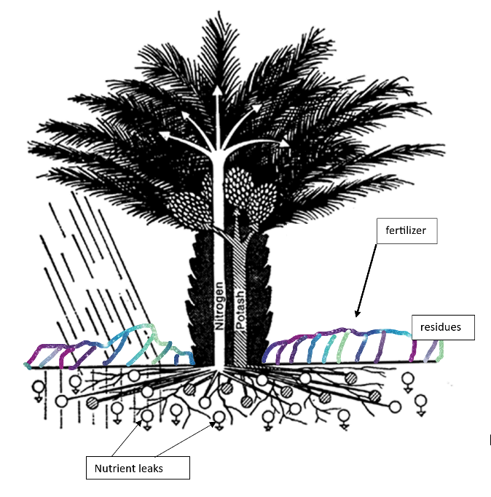
Illustration 1: Plantation without and with biochar
Although it is generally recognized that biochar improves the productivity of agriculture, it has not been quantified yet and can only be defined by field tests. Essential will be to convince the agricultural industry that biochar is a big win for them, be it to save fertilizer, sequestrate carbon or developing a profitable biofuel side business.

Accessibility of residues
Assuming that tropical soils are improved by addition of biochar and residues can be taken away from the field, still logistic issues will remain as very wet and bulky biomass must be transported to a biofuel refinery or gasification power plant.
As yield of agriculture products is relatively low, vast area of land are cultivated to produce the required quantity of crop. Transport of crops on the plantation is often done manually to collection points where they are loaded on small trucks bringing their load to the nearest processing plant, which is often 10 to 30 km away from the loading point.
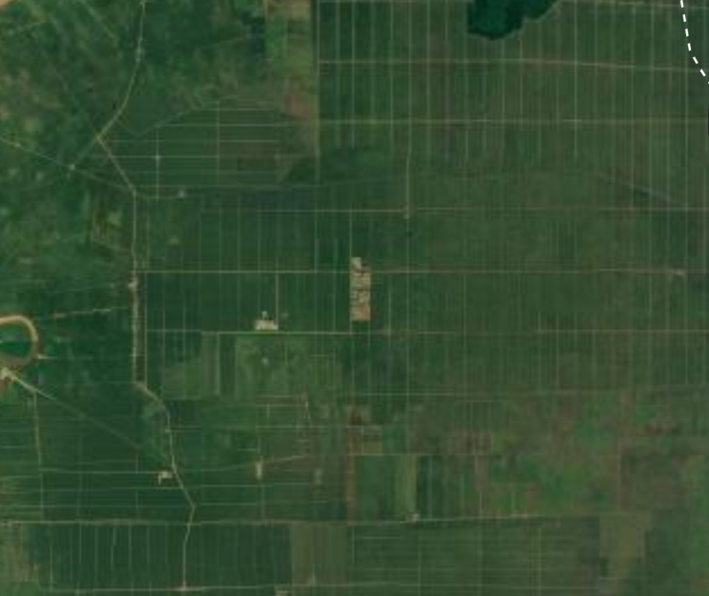
Internal transport, partly manual, partly by small trucks is slow and difficult. Transport is slow as the roads are of poor quality and most of the time just unhardened dirt roads even sporadically flooded during rainy season.
E.g. a palm oil mill will process production from a plantation with area between 3,000 and 10,000 ha (5,000 ha = 50 x 50 km).
mill
At the mill, residues must be transferred to bigger trucks for external transport.
The distance to the nearest port/industrial area is often up to 250 km, a distance that will take up to 6 hours for a truck in very dense and dangerous traffic.
Energy density of average non treated biomass is 25 times lower than that of coal, due to high moisture and light product. Additionally, the biomass will loose very quickly its value as due to the hot and wet weather it decomposes during transport and storage.
Untreated biomass residues in the tropics are, because of cost, not accessible, but if processed in the mills and converted to ‘biocoal ‘ transport cost is not an issue anymore. The conversion process consists of shredding, drying, cutting, torrefaction and pelleting. The off gas released during torrefaction is used as fuel for drying. The biocoal is hydrophobic and has very low moisture content (5% H2O), making any further drying before syngas gasification unnecessary.
The biocoal is an ideal clean feedstock for syngas gasification or gasification power generation, as the dirty components (tars, chlorines, ...) and water have been extracted already during torrefaction.
Theoretically biocoal can be transported over long distances even be exported and shipped, however as biochar and ashes are to be returned to the plantation, syngas gasification and biofuel(methanol) plants should be in a port or industrial area, not far(+- 200 km) and central to the plantations from which the feedstock is supplied. From there, e.g. “Green Methanol“can be exported worldwide.
Although under above scenario bio residues in the tropics are available and accessible it will depend on the agricultural industry if and under what conditions biofuel production from residues can be developed.
This industry owns the biomass and therefore it is the agri-industry that will decide if it wants to make the switch to market this feedstock or not.

Conclusions

- Agricultural residues are available if tropical soils are enriched with biochar.

- Extraction of residues from plantations must be in balance with the amount of biochar returned to that same plantation. Nutrient balance should be neutral or positive not to affect growth of plants.
Production of biochar must be an integral part of the “residue to biofuel” production chain and must be proportional to the residues extracted from plantation.
Logistic cost must be minimized by integration of biocoal production, thus converting the biomass to high density and hydrophobic biocoal. Gasification should be nearby and centralized to minimize transport cost of delivered biocoal and returned biochar/ashes.

- As the biocoal production is a mild gasification, dirty tars and dust are already removed; it allows the gasifier to produce much cleaner syngas, thus reducing the investment cost for gas cleaning equipment to the methanol reactor.

- Agri- industry is the key player.

